|  |  |
| --- | --- |
| Who is this tool for? | Project team  Condominium manager (syndique) |
| What is the purpose of this tool? | This tool will help to develop a relevant plan about the building phase of the retrofitting for your fellow residents. It will help to inform the other owners of the plans and of the implication for their daily life. |
| How to use this tool? | In the overview you can click on each of the elements to obtain more information. This is where you will find useful templates. |
| Next steps | Celebrate your retrofit! Also see communication: the tips once the retrofit is completed |

By now you have chosen a building company, you know what will be done in your building, you’ve secured finance and permits, and residents have voted for the retrofit to be done. Your builder will have shared (fairly technical) plans about the retrofit. These plans include information about what will be done, how it will be done, how much it costs and approximately when it will be done. However, as the condominium project team you are the linking pin between the builder and the co-owners. Your task is to inform the other residents of the plans and of the implication for their daily life. You are also representatiing the owners towards the builder in case problems arise. The tips in this document are about managing the project and performing your role as linking pin.

**Overview**

Click on an element to get more information

# Overall plan

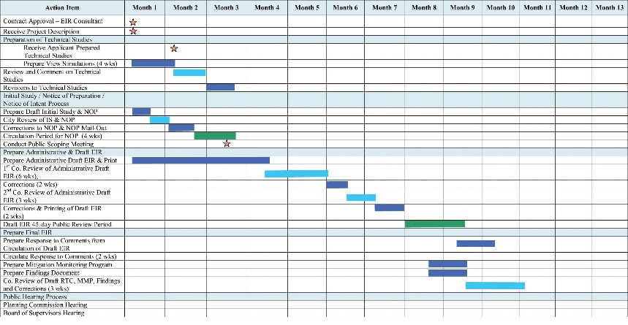On the basis of the plan the builders provide, prepare an easy to digest overall plan for the owners, for instance in the form of a calendar, and indicate the estimated start and end time when certain works will start. Also you need to indicate the expected delivery.

# Template for making your own plan

**(copy into a word document)**

|  |  |  |  |  |  |  |  |  |  |  |  |  |  |
| --- | --- | --- | --- | --- | --- | --- | --- | --- | --- | --- | --- | --- | --- |
|  | Month 1 | | Month 2 | | Month 3 | | Month 4 | | Month 5 | | Month 6 | | Expected delivery, e.g. ventilation shafts upgraded, new central lighting ready. |
| Task 1 |  |  |  |  |  |  |  |  |  |  |  |  |  |
| Task 2 |  |  |  |  |  |  |  |  |  |  |  |  |  |
| Task 3 |  |  |  |  |  |  |  |  |  |  |  |  |  |
| Task 4 |  |  |  |  |  |  |  |  |  |  |  |  |  |
| Task 5 |  |  |  |  |  |  |  |  |  |  |  |  |  |
| Task 6 |  |  |  |  |  |  |  |  |  |  |  |  |  |
| Task 7 |  |  |  |  |  |  |  |  |  |  |  |  |  |

Back to overview

# Detailed plan

For every main task you need to identify (with the builder) what this means for the owners. For instance, they might have to clear their balconies, or the elevator might be out of order, or they cannot cook for some time, or water will be cut off. You can split this up in

* Preparation needed
* Inconvenience to be expected

Now you need to discuss this with the owners and the builder: are measures required to help with preparation or to deal with the inconveniences? Add the proposed measure to the overview and share this with the owners and the builder.

# Template for making your own detailed plan

(copy into a word document)

|  |  |  |  |  |
| --- | --- | --- | --- | --- |
|  | Preparation needed | Inconvenience expected | Solution needed? | Agreed solution |
| Task 1 | e.g. Clear balcony by 21 November | e.g. Noise during the whole period | e.g. App. No. 10 has an exam in week 3: can this task be stopped then? | e.g. App. 220 offered another workplace for the student in this period |
| Task 2 |  |  |  |  |
| Task 3 |  |  |  |  |
| Task 4 |  |  |  |  |
| Task 5 |  |  |  |  |
| Task 6 |  |  |  |  |
| Task 7 |  |  |  |  |

Back to overview

# Prepare monthly/weekly overview

It is a good idea to provide up-to-date information on a weekly and/or monthly basis based on your overall plan and actual progress. This is also the moment to update the co-owners on any delays. Don’t forget also to mention what has been achieved since the last reporting period. See below for the elements to include.

Be very transparent in your communication: if a delay has occurred, mention this. You will have to take into account that a few owners always follow the process very carefully and will start to ask why task x has not been completed on time if you don’t update them regularly. Owners will be more positive and understanding if they know what is happening. See “communicate with your neighbours” for tips on how to communicate with the owners.

# What to include in the weekly/monthly updates

1. Per week/day what tasks are worked on
2. What preparation is needed/preparation deadlines
3. Expected inconvenience and solutions
4. Progress compared to initial schedule
5. Achievements
6. Delays and their reasons
7. Upcoming meetings/excursions

Back to overview

# Involve the builder

Organise meetings where the owners/residents can put their questions to the builders. Also ask the builder to organise once in a while, when there is something interesting to see, a short excursion to show how the work is coming along. Make sure to agree on this with the builder in the project preparation phase.

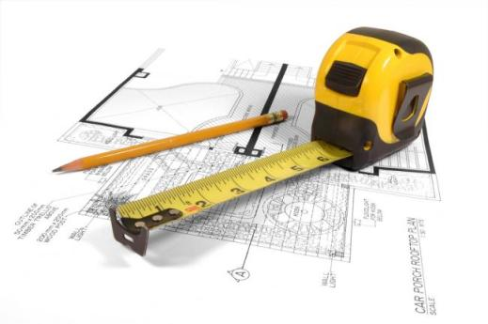

Back to overview

# Dealing with complaints

Ensure that anyone with a complaint can contact the project team at all times, e.g. via a whatsapp group address or any other convenient method of communication. Make certain that this contact address is clearly visible in the building entries and on all communication. However, don’t frame it in a negative way such as “complaints: let us know” but as “ Any questions regarding the retrofitting can be directed here”.

Once you receive a complaint, immediately send a confirmation of receipt.

Then decide how serious the complaint is, how to deal with it, and who should deal with it. Sudden cracks in walls need urgent attention from the builder, but an exhausted parent with a sick child complaining about noise might require someone within the condominium who passes by for a friendly chat.

Make sure to keep track of complaints, see below

# Template for a complaints logbook

(copy into a word document)

|  |  |  |  |  |  |
| --- | --- | --- | --- | --- | --- |
| Complaint | Complaint by | App. No. | Seriousness (mild, intermediate, urgent) | Follow-up | By whom |
|  |  |  |  |  |  |
|  |  |  |  |  |  |
|  |  |  |  |  |  |
|  |  |  |  |  |  |
|  |  |  |  |  |  |
|  |  |  |  |  |  |
|  |  |  |  |  |  |

Back to overview

# After the project

Once the project is complete, everybody will want to know what was achieved and how much it finally cost. Also, it is a good idea to have a look at the benefits that were promised and the extent to which they were achieved. It is a good idea to prepare a summary and to discuss the findings in a meeting. Don’t forget to celebrate the completion of the project. Some elements to include in the summary:

1. A list of what was done in every step (e.g. roof renewed – new isolation installed – solar panels installed, e.g.)
2. Overview of all costs, if possible break down by project step (e.g. roof: 30,000).
3. Overview of complaints and solutions
4. Compare if promised benefits were achieved and if yes, list them. If not, explain why promised benefits could not be achieved (e.g. The strength of the roof didn’t allow …)

See “communication” for tips on how to communicate with the owners after the retrofit.

Back to overview