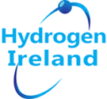

The commodification of Green Hydrogen for Europe

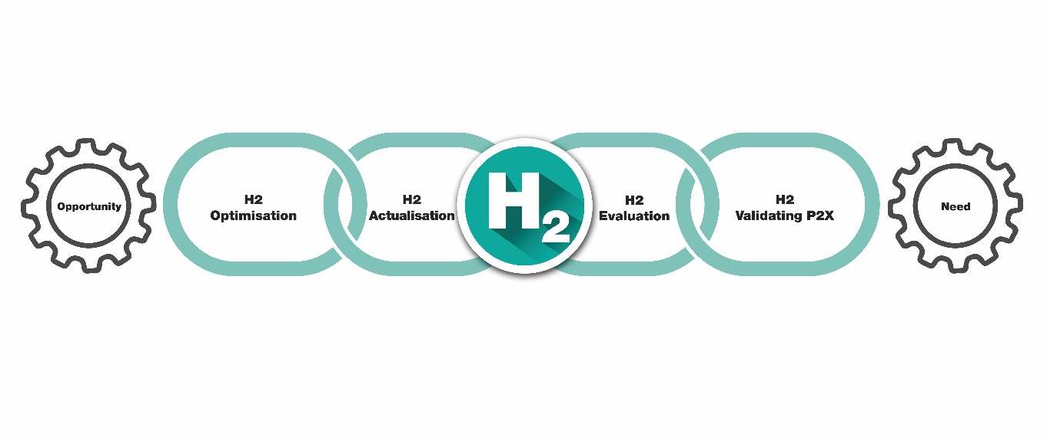
Introduction

We are at one of the most pivotal times in the Energy industry, facing climate and security challenges. The urgency is driving industry, communities, and society through an accelerated energy transition.
The drive to reduce our carbon footprint energy security has powered companies to unprecedented levels of innovation, transformation, productivity, and efficiency.
As we embrace a rich future of sustainable energy, catalyzed by Green Hydrogen (Green H2) we are examining every step in the four stage Green H2 Commodification value chain to enable this transformation for all.

REPowerEU is the European wide strategy seeking greener alternative energy sources to power European industry and society. To populate this strategy, we must accelerate the hydrogen revolution, and make hydrogen an everyday commodity. Commodification is the transformation of things such as goods, services, ideas, nature, personal information, people, or animals into objects of trade or commodities, that are everyday items. For our energy journey to be widely accepted and deployed we must replace fossil fuels with a commodity that brings a seamless change.

Europe faces multiple pressures to decarbonise economies and to address the urgent need to achieve EU energy independence by accelerating the integration of greater renewable energy sources into our energy systems. Enabling increasing integration of greater renewable energy sources into the energy mix can be achieved with hydrogen as one of the tools in the toolbox of decarbonisation and key green energy vector which will result in exponential growth of the green energy market.

What will be Hydrogen’s role in the final energy mix of a future net-zero emission Europe? This session will examine how we can optimise the use of Hydrogen for it to become an energy commodity and to accelerate the decarbonisation journey for Europe by utilising Green Hydrogen as a key energy vector.

Hydrogen as an Energy Commodity

Energy is a commodity and if we are to integrate hydrogen into our energy supplies then we must strive to make hydrogen a commodity to ensure the transition is seamless.

How can we position Hydrogen technically and environmentally to become an energy commodity? Examining and detailing the key steps in the 4-stage Green H2 value chain, production, storage and use to maximise green energy outputs and accelerate the transition to net zero.

To meet Europe’s needs with green solutions we must develop innovative sector coupling technologies and strategies, new energy models to achieve widespread use of secure renewable energy and how the deployment of existing and new technologies with industry stakeholders/customers alongside appropriate policy, provides commercial and investor confidence.

As we address the challenges of decarbonisation, rising energy prices and increasing issues of energy dependency hydrogen as a clean energy vector with national energy value chains is poised to play a significant role in increasing domestic energy independence, developing sector coupling opportunities and in creating new networks of European collaboration.

In today’s world of recovery post COVID-19 and as we seek to tackle the climate crisis hydrogen is a vital factor in the emerging green energy equation, capable of integrating greater factors of renewable energy sources, energy innovation and delivering energy solutions capable of achieving net zero.

Clean Hydrogen will play a significant role in increasing domestic energy independence as well as enabling new networks of international collaboration. As
Europe switches from fossil fuel dependence to renewables and clean hydrogen it will create diversification and achieve energy security.

4-Stage Green H2 Commodification value chain

As Europe creates a new frontier for clean technologies with clean hydrogen as the transformational key energy vector we need to examine and maximise each of the links in the 4-Stage Green H2 Commodification value chain, optimisation, actualisation, evaluation, and validation

We must ensure that these 4 links are synchronised, are no gaps or losses in the system and balanced so we can get the optimum output from each and collectively. If Europe can achieve a system synergy in Green Hydrogen and a system balance it will deliver outputs where the whole is greater than the sum of the parts.

OPTIMISATION
ACTUALISATION
EVALUATION
VALIDATION

Title: The 4-Cogs of Green H2 synchronisation

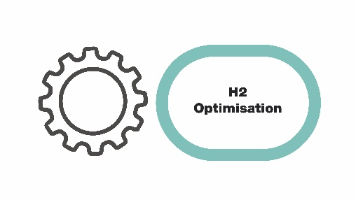
H2 Optimisation

Hydrogen is the catalyst driving Europe’s energy transition, enabling us to pioneer new and innovative paths to sustainability. Optimising this journey, enhancing its cost-competitive production, storage, and end-use is critical.
Delivering SMART H2 through valorization of the hydrogen supply chain, production, storage, and use is key to creating a successful, sustainable secure energy future for Europe.
.

Optimisation of Green H2 – building on the Hydrogen topography, developing, and deploying geographical Green H2 specialisms dependant on the local renewables and availability. A geographical approach preferable to a widespread sectoral approach leading to increased demand/deployment. This approach empowers communities across Europe to access hydrogenewables, their own renewable opportunities wind, solar, bio, wave, tidal, geothermal and use these green sources to provide green energy solutions on their specific journey to net zero. It also enables the ppositioning of relevant Green H2 energy solutions to address regional opportunities, challenges and objectives and build regional energy secure communities with their foundations in local renewables.

There are many challenges governments face today on our journey to achieve the twin goals of long-term sustainability and secure indigenous clean energy systems.
There is no ‘one-size fits all’ approach to reaching net-zero — technologies across all sectors of the economy will need to work together. And these technologies are all at varying stages of research, development, and demonstration (RD&D).
We must also look to achieving efficiencies from every step on this journey and secure the most effective energy opportunities each step brings – a Green H2 NEXUS.

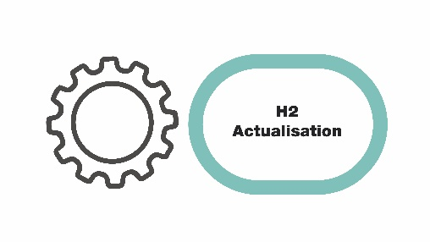
H2 Actualisation

The 2020’s was heralded as the decade of action in the fight against climate change. Hydrogen is universally recognised as having a significant role to play in the move away from fossil fuels, but we now urgently need a holistic, agile approach to address existing barriers and to drive costs out of the supply chain if this really is to be the decade of action. There is no time to waste.

Urgent action is needed to address barriers for hydrogen to become an actual viable market and meaningful part of the future energy mix. Suitable policy frameworks that de-risk projects and bring confidence to investors are critical alongside fit-for-purpose regulations, codes, and standards to allow safe, efficient technology deployment. Fundamentally we will need more renewables on a massive scale, both for the green electrons but also to generate green hydrogen which will be needed to decarbonise hard to abate sectors. We need robust supply chains; we are already experiencing fragility in various parts of the value chain even at this early stage of market development creating delays to project onstream and threatening the economic case; so, we need to put in place support to sure up supply. Supply and demand need to grow in step to enable business cases that make commercial sense and that will be supported with finance. Finally, agility and innovation in engineering approaches to project development and delivery will be key to moving projects successfully through FID and into operation.
Acceleration in all parts of the hydrogen value chain is now needed if we are to meet near and long-term carbon emission goals.

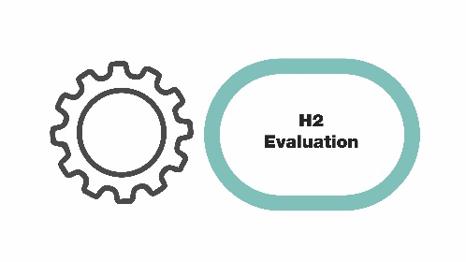
H2 Evaluation

Hydrogen can be the key to creating a successful, sustainable, and secure energy future for Europe. But it is people who need to open the door. It is crucial to understand and consider people's needs and attitudes around hydrogen to make the transformation process socially valuable and viable. After all, the successful implementation of any innovation process depends on more than technological functionality or a suitable economic and institutional environment. It takes relevant stakeholders and the public to come together and show support for the process and willingness to invest time and effort. Therefore, to successfully target the commodification of green hydrogen, it is equally relevant to target a consensus on its social value and desirability. To achieve such understanding, people need to develop an overall positive attitude towards hydrogen and the process that comes with incorporating it in the current system. Without acceptance of the technology by relevant stakeholders, it would not be applied, and the transformation process would remain stagnant. The mere compilation and communication of information are thereby not sufficient to build, upkeep and enhance public acceptance. Only by understanding how hydrogen technologies are perceived and evaluated and which group and individual level parameters are decisive in the evaluation process, we can develop productive communication strategies and interventions to influence the outlook of stakeholders on hydrogen technology and thereby optimize and enhance public acceptance and involvement. However, there is still substantial work needed on understanding behaviours and attitudes around energy use, and on mechanisms for supporting households and communities throughout the energy transition. Still, in our drive for technological development, we cannot ignore the central role played by people; we must ensure that we are also fostering innovation and collaboration at the social level because technology alone will not achieve our net zero goals.

It’s not only about energy, but it’s about democracy: when people get empowered about their energy production […] it empowers them as well as a citizen, as part of a democracy

Dirk Vansintjan - President at REScoop.eu and EUSEW Digital Ambassador

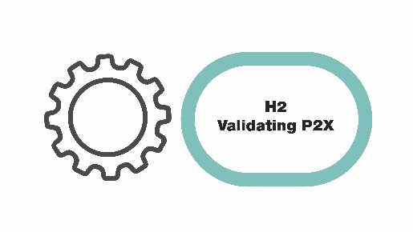
H2 Validation

We need to speak to the End Users, those whose jobs it is to decarbonise and strengthen energy security. We cannot promote “hydrogen for the sake of hydrogen”. We must find the right roles. Industry-Research collaborations are essential for enabling clear-headed, objective decision-making

Validation of the use of Green H2 and accelerating through the creation of a techno-economic model enabling support tool. Europe finds itself in the middle of a H2 energy revolution and crisis –where all of Europe must be informed, assisted, and enabled to transition from fossil fuels to a net zero C02 destination. Hydrogen is no longer an ’if and why’ it is now ‘when and how,’ as we work toward optimising the commercialisation of renewable hydrogen technically and financially. As the EU green energy revolution continues, authorities and agencies need to be able to access up to date information and key data analytics outputs to support and encourage confidence to support their green energy planning. The GenComm project has produced a validation tool the Enabling Support Tool (EST) – a dynamic and collaborative decision support tool involving regional stakeholders. This is one aspect of a regional empowerment strategy for communities to play an active role in energy transition.

Based upon the original Decision Support Tool (DST) the EST reconciles the challenges faced by both renewable sources and hydrogen technologies in the current energy context and facilitates the creation of opportunities empowering the planning and deployment of Green Hydrogen. The EST allows demand and production to be ‘matched’ in a model and application tool enabling forward planning, stimulate investment in coordinated application, and supply infrastructure.

The EST will enable the transport sector to decarbonise. Initially focussed on public transport, it will also open opportunities to other hard to decarbonise mobility sectors – trucks and trains. Regional clustering of demand will facilitate larger supply hubs co-located with either industrial hydrogen applications or other value chain enhancing opportunities i.e. sale of co-produced oxygen. This will enable road transport to access the recently announced hydrogen truck incentives to use Europe’s roads.

SMART H2

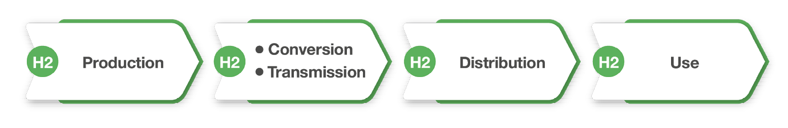

Title: The SMART H2 Process

To achieve successful energy transition to renewables in Europe we must look to achieving full commercial opportunity for renewable energy. To achieve this, we must ensure commercial flexibility in the coupling of the renewable energy sector and the transport sector.
The use of SMART H2 (Hydrogen produced from renewable energy sources) as an energy carrier to achieve this goal is crucial.
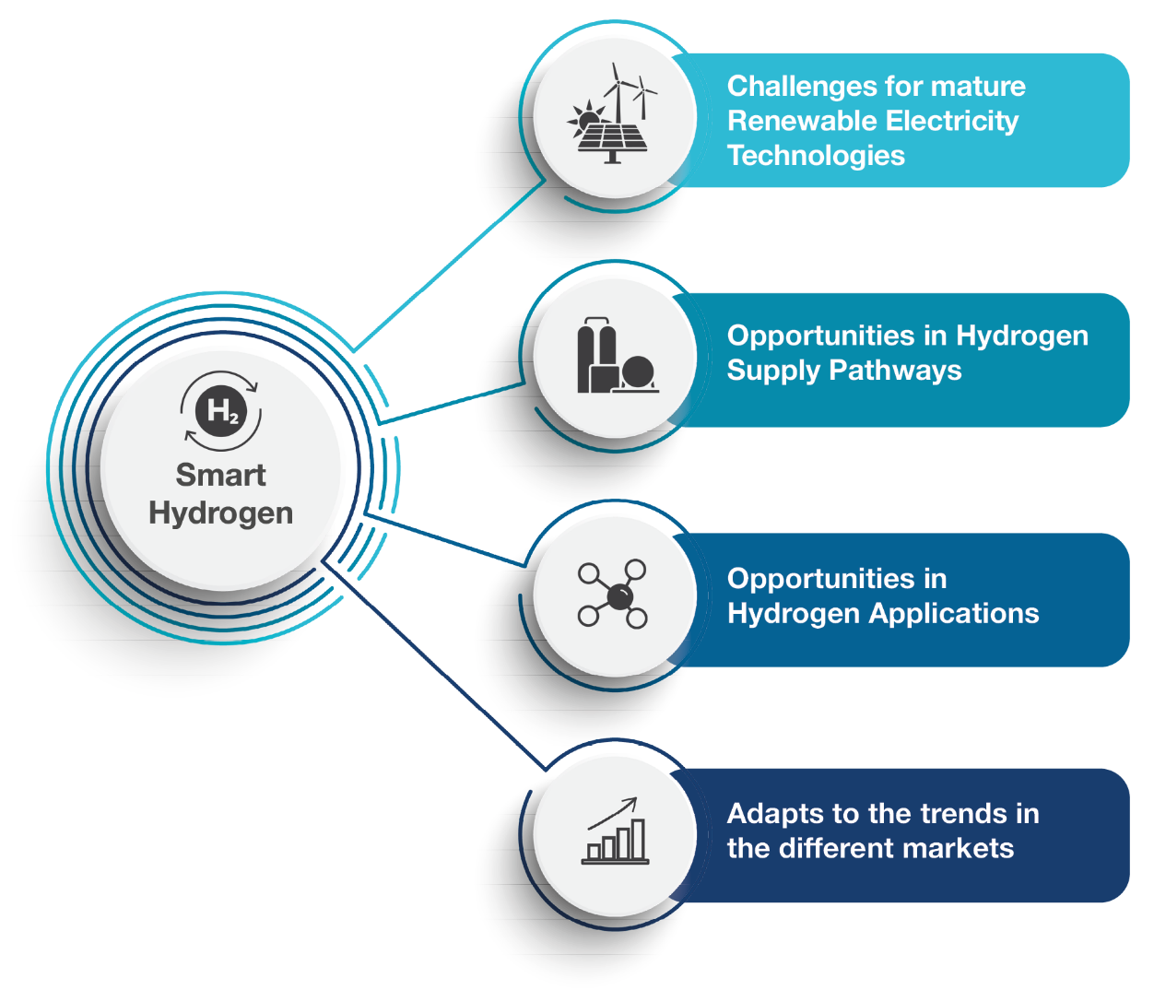

Title: The SMART H2 Sector Coupling Opportunity

TRANSITION OPPORTUNITIES

As Europe transitions to net zero and we deploy more green energy vectors such as Green H2 , we must position as the lead economy in clean hydrogen trade and accelerate our current EU clean hydrogen journey. We must build and populate a trans-European Hydrogen Highway with on and off ramps for all technologies and opportunities. It is imperative that we develop increased additional links with other partners to accelerate this journey and stimulate increased Green H2 awareness for demand and ‘position’ these new energy transactions where they deliver maximum environmental, commercial, social, and environmental benefit.
To stimulate industry, commerce, and academia we should develop a European Hydrogen Catalyst – H2 CAT that will stimulate the transitioning European economy towards a climate-neutral and more resilient economy. We are at the leading edge of this hydrogen economy and must front load the opportunities. Once they reach critical mass the catalyst can then become a Hydrogen Catapult to accelerate the transition. The Expand our work to include digitalization and implementing a well-thought-out circular economy model.

Digitalisation

The Green Economy is predicated on the Green Economy and Digitalisation. We can use digitalisation and digital tools to optimise value at every stage in the Green Hydrogen value chain. Blockchain will be a powerful tool in tracking emissions and green molecules along energy value chains As we prioritize green hydrogen in the energy transition this will drive profound change and deliver new policies, business models, and regulatory models in the rapidly changing energy sector. Blockchain and other digital tools will play a prominent role in supporting these strategies.
Blockchain will disrupt today’s energy industry and will enable stakeholders to reap substantial benefits for years to come.

Gearing UP

As we build the fundamental basics of the hydrogen value chain and achieve commodification, the challenge then remains how do we scale this to meet national and international needs and accelerate the development, deployment, and use in applications. We need to add in external inputs that will multiply the outputs from the basic hydrogen value chain. Once we have 4 Stages, optimisation, actualisation, evaluation, and validation of the Green H2 Commodification value chain locked together we can then start to ‘move up the gears’ and accelerate the process to meet the energy needs of Europe. In the early days of cycling there were rear gear hubs fitted to the rear wheel of the bicycle which were limited to mostly 3 gears. As a result, this lack of choice had a direct result in limiting speed, acceleration, response to terrain and ultimately limited progress. This was enhanced when an additional 3 or 4 chain rings were added at the front of the chain which allowed for greater gear ratios, choice, speed of response and acceleration. The 4 stages of the Green H2 Value Chain are the new primary cogs in the new hydrogen economy they are the ‘Hydrogen Cassette’ however for us to build multiplication and acceleration into the equation we need to add additional ‘multiplication chainrings’ to the process. These additional cogs such as legislation, market demand and innovation will effectively change the range of our gears and response appropriately and will provide greater ratios in Green H2 response. The addition of these chainrings provide more options for an emerging hydrogen economy, also enabling a regional response as part of an international effort, to respond appropriately to the changing energy terrain and agility in responding to conditions effectively and efficiently. The addition of additional chainrings in the Green H2 value chain will enable us to gear up, accelerate with greater effectiveness and efficiencies and importantly reinforce the roll out of hydrogen topography for the different regions of Europe. Once we get the basics locked in, we can then ramp up the process to create the European H2 Highway, on ramps for hydrogen accession countries and importantly fast lanes for development and deployment.

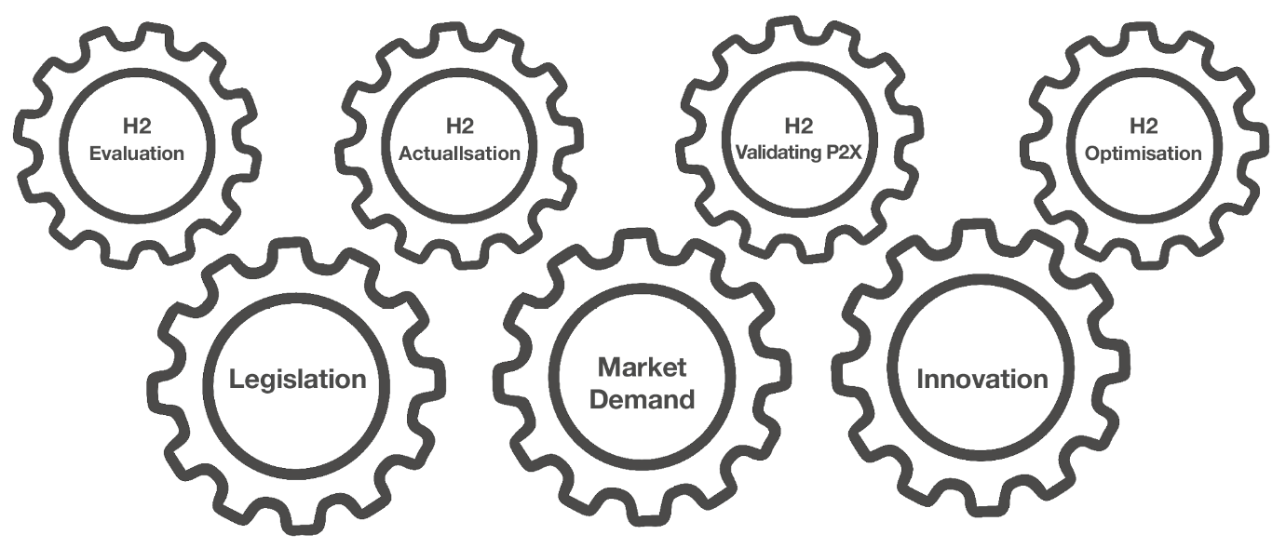
Title: The Green H2 Gear system

Conclusion

Green H2 plays a twin parallel critical role of delivering the EU’s long-term decarbonisation goals and being the foundation stone of the EU’s energy independence. With Green H2 as the catalyst Europe can develop our renewable energy technologies exponentially, take control of our energy supply chains and become masters of our own energy destiny.
Green H2 is a disruptive technology – it is nonlinear change in a linear world and as such our approach must reflect this. We are looking to decouple the old energy model and implement a new integrated energy model that places the customer at the front of the process not at the end. Disruption, by definition, changes the “traditional way of doing things” and accelerates change and transformation. We must optimise all steps of Green H2 in a logical, needs driven, exponential accelerated manner to fully exploit current and future clean energy applications.

Energy innovation is not linear it is a conversion and Green H2 innovation can and will convert our energy systems to the green alternatives we need to fully transition to a new zero carbon energy model with Green H2 as a constituent vector we need a different energy market structure. One which will deliver on the renewables opportunity and provide us with renewable capacity and flexibility.

Green H2 is 360° effective across the 4 sectors of a circular economy.
- Environmental – it has a zero-carbon footprint
- Social – it is a community inclusive energy solution
- Commercial – it is a key energy catalyst assisting industry pivot to green solutions
- Financial – Innovations in electrolysers will ensure that Green H2 will become more cost effective than natural gas

Title: The 4-Stage Green H2 Commodification Value Chain

Responding to our climate and energy crisis requires us all to act. It needs a collaborative ‘all hands-on deck’ effort with governments, scientists, innovators, industry, and communities all working in cohesion as partners in the clean energy transition that will deliver the solutions we require and contribute to our understanding of climate change and its impacts.

The green energy transition is fragile. Today’s energy price rises are exposing challenges in market design and regulation, creating the need to reshape.
Across the globe and especially in Europe nations are turning to fill gaps in their fossil fuel supplies by looking to reopen coal mines, expanding domestic gas production, and securing new import contracts. This new landscape offers difficult terrain for the clean energy transition. Renewed energy security concerns among many nations risk pushing clean energy ambitions back down the agenda while short-term crises are tackled.

‘Near term challenges shouldn’t obscure real opportunities.’

Contributors
- Bart Biebuyck Executive Director of the Clean Hydrogen Partnership
- Paul McCormack Innovation Manager Belfast Met
- Diana Raine Worley
- Marianna Rossi IZES
- Rory Monaghan Galway University

Contact:
paulmccormack@belfastmet.ac.uk

