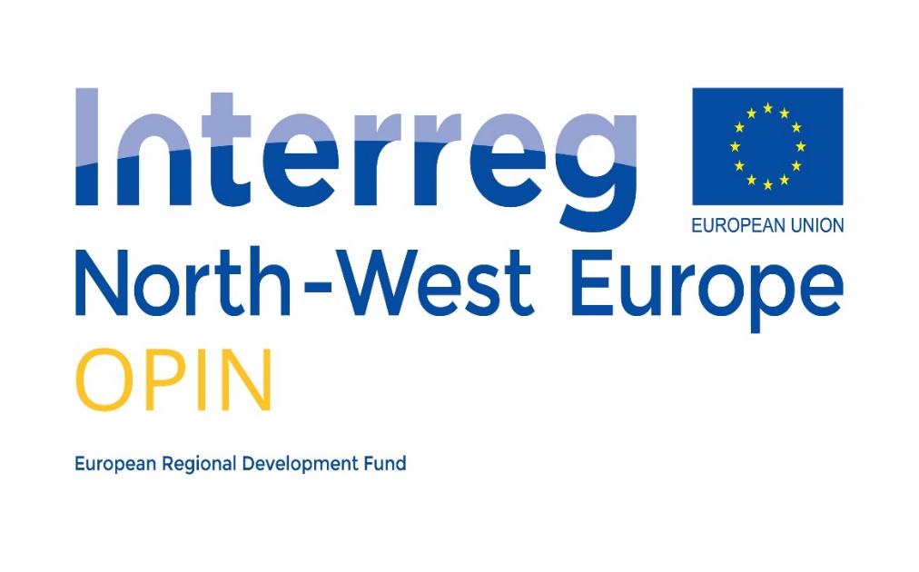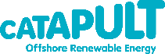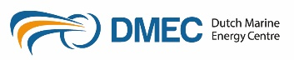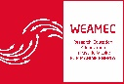

Ocean Power Innovation Network
Travel Support

Application Form

Applicant Guidelines
- Travel support is available to a maximum of €500 per trip (including VAT) and €2,000 per SME.
- Travel support is only available to Irish and Scottish Enterprise area SMEs, attending an OPIN workshop, masterclass or Collaborative Innovation Group meeting outside of their region.
- The award of travel vouchers will be discretionary and based on need for assistance and potential value of the activity to the SME or Collaborative Innovation Group.
- Travel must be approved in advance by the appropriate OPIN partner (Sustainable Energy Authority of Ireland or Scottish Enterprise).
- For further details see the OPIN Travel Support Guidance to Applicants document.

Applicant Details
Please fill in the requested information in Table 2.1 below:
Organisation Details
Organisation Name
Organisation Address
Legal Status
OPIN Region
Country
Contact Details
Contact Name
Contact Telephone
Contact Email
Recipient Details (if different form contact)
Recipient Name
Recipient Telephone
Recipient Email
Table 2.1: Applicant Details
Notes:

Legal Status: SME = small or medium sized enterprise; IND = large enterprise; HE = higher education / University; RO = research organisation

OPIN Regions: Ireland, Scottish Enterprise area.

Event Details
Please provide details on the OPIN event you are applying for support to travel to in Table 3.1 below:
Category | Details
Event Name
Event Organiser
Event Location
Event Date
Table 3.1: Event Details

Cost Details
Please provide, in as much detail as possible, costs associated with this trip to be covered through the Travel Innovation Voucher in Table 4.1 (the maximum value of a Travel Innovation Voucher is €500 incl. VAT).
Item | Description | Estimated cost
Table 4.1: Cost Details

Justification of Support
Please note that this section is limited to a maximum of one page. Please address the following points:
- Is your company developing a technology, product or process relevant to the ocean energy sector? Please describe the product, potential uses and current status.
- How will attending this OPIN Symposium / Workshop / Masterclass / Collaborative Innovation Group meeting help with product development?
- What is the role of the attendee in your organisation and why are they the appropriate representative at this event?
- Why do you require travel support to attend this event?

