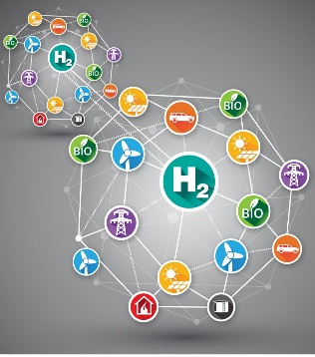
GenComm Conference 2023

GenComm the Sat Nav for Green H2 deployment

Date: 31st May

Venue: Belfast Metropolitan College

AGENDA

08:30 – 09:00 Registration

Part 1 Deliverables 09:00 – 13:00 hrs

- 09:00 – 09:15 Welcome address – Paul McCormack Belfast Met
- 09:15 – 09:20 Belfast City Council Lord Mayor Tina Black
- 09:20 – 09:35 Powering the Green Economy - Louise Ward Hunter Chief Executive Belfast Met
- 09:35 – 09:50 Interreg North-West Europe - Gina McIntyre SEUPB
- 09:50-10:05 Clean Energy - Eva Clymans Senior Project Officer Interreg North-West Europe
- 10:05 – 10:20 Hydrogen Mobility – William McCullagh General Manager – Translink
- 10:25 – 10:45 Green Molecules - David Butler Director, SGN Natural Gas
- 10:45 – 11:00 Q&A

11:00-11:20 Tea/Coffee

- GenComm Micro H2 Hubs
  - 11:20 – 11:45 Wind – Andrew Morrison Energia
  - 11:45 -12:00 Solar – Dr Bodo Gross IZES

- 12:00 – 12:20 The KoNSTanZE /eH2cycle project –Dr Michael Reinstaedtler BOSCH
- 12:20 – 13:00 GenComm Enabling Support Tool – Branca Delmonte University of Luxemburg, Tadgh Cummins University of Galway, Tim Williamson HY Energy

13:00 – 14:00 Lunch

Part 2 Influence/Impact 14:00 – 18:00hrs

- 14:00 – 14:20 Community Hydrogen Forum – Ch2F - Dr Rory Monaghan University of Galway
- 14:20 – 14:40 SH2AMROCK H2 valley – Ian Williamson HY Energy
- 14:40 – 15:00 Hydrogen Triple Alliance – Paul McCormack Belfast Met
- 15:00 – 15:20 Hydrogen Ireland – Mark Welsh H2Irl
- 15:20 – 15:40 HyLight – Dr James Carton Dublin City University
- 15:40 – 16:00 Hydrogen Training Academy - Alan Reid Northern Regional College, Connor Dornan Mid & east Antrim Council

16:00 – 16:20 – Tea/Coffee

- 16:20 – 16:30 Associate Partner presentation Ursula Conlon Louth County Council (TBC)
- 16:30 – 16:45 Hydrogen Skills Further Education/Higher Education cohesion– David Rooney QUB, Chris Corken Belfast Met
- 16:45 – 17:00 Climate Action Plan –– Kevin Hegarty DAERA
- 17:00 – 17:15 Energy transition – Eddie Kerr DfE
- 17:15 – 17:30 The Green Economy -Sam Knox Invest NI
- 17:30 – 17:45 Amazing clean energy technologies/communities – to infinity and …? – Dr Mark Palmer QUB Dr Nicola Barron QUB

- 17:45 – 18:00 Q&A and Conclusion

- GenComm Website nweurope.eu/gencomm
- GenComm LinkedIn GenComm
- GenComm twitter @GenComm_CH2F
- Community Hydrogen Forum www.communityh2.eu
- GenComm Animation https://vimeo.com/366993950/91cafb0bb6

E-mail - PaulMcCormack@belfastmet.ac.uk

