BioBase4SME Innovation Biocamp application form
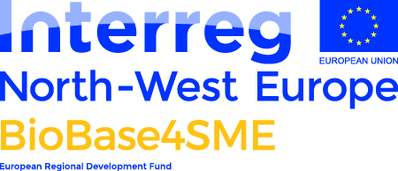
This application form is for participation in the BioBase4SME BioCamp which runs 23-28 July 2017 near York in the UK. The deadline for applications is 19/05/17. Please note that places on the Innovation Biocamp are exclusively for representatives from innovative, bioeconomy-related companies that have incorporated within the past 5 years (or are planning to incorporate in 2017), have less than 250 employees and turnover below €50M. Your company must be based in the Interreg North West Europe area: http://www.nweurope.eu/about-the-programme/the-nwe-area/. Our criteria for evaluating applications can be found at: http://bit.ly/2n0yV0q
If you have any questions, please contact info@biovale.org or ring +44 (0)1904 32 8045.
__________________________________________________
- Email address:
- Name:
- Company Name:
- Company Address and postcode:
- Phone number:
- Website address (if applicable):
- What is your company turnover:
- €0-100k
- €100k-1M
- €1M - 10M
- €10M - 50 M
- greater than €50M
- How many people do you employ
- 0 - 1
- 1 - 10
- 10 - 150
- 50 - 250
- When was your company incorporated?
- Does your company operate in the bioeconomy? (for a definition of the bioeconomy see https://www.biovale.org/the-bioeconomy/)
- Yes / No
- Does your company have a base in the Interreg North West Europe area?: http://www.nweurope.eu/about-the-programme/the-nwe-area/.
- Yes / No
- What is the key innovation that your company offers? Describe your company’s product or service. Explain your key idea / intellectual property and how your it responds to the need you identify below; how it improves on existing solutions. (max 200 words)
Question 12 Your answer here

- Who will buy your product or service and why? Describe the business need that your product or service satisfies and why new innovative solutions are needed. (max 200 words)
Question 13 Your answer here

- What is the value of the market which your company addresses? Specify the markets your company is targeting, their size, structure, dynamics, predicted growth rates, the main supply/value chains and any barriers to entry. Include issues related to the three pillars of sustainability. (max 200 words)
Question 14 Your answer here

- What is your vision for the company in 1 and 5 years' time? Outline your strategy for growing the company. What are the key milestones you hope to achieve by July 2018 and 2022? (max 200 words)
Question 15 Your answer here

- What do you hope to gain from attending the Innovation Biocamp? Describe what you are hoping to learn from the Biocamp and why you think it will help you grow your company. Please specify any particular areas where you are looking for mentorship or training. (max 200 words)
Question 16 Your answer here

- Please attach a short CV (<2pages)
Please return the completed form to info@biovale.org by 19th May 2017
We will get back to you by the first week in June to let you know if you have been successful

