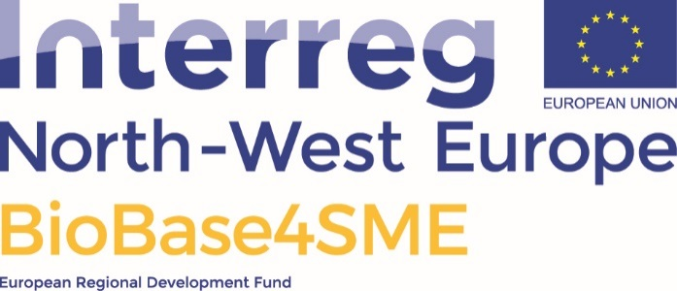

BioBase4SME innovation coupon application template

Application form to apply for a BioBase4SME coupon. The length of the application is expected to be about 4-5 pages

Bio-innovation agent:
[name]

Your contact information:
Company name and address
Contact person name, email, telephone, address, role in the organisation
Short description of your company’s activity

Short title of the project (This is for easy reference)

Brief description of the problem to be addressed (about 4 pages)
This information is used to judge the potential of the idea, and to make the selection. Please note that we are aware that you request services to be able to answer the questions below more adequately.
Please number the answers.

- General problem description and Challenge

- The Innovativeness of the provided concept/solution
How does your innovation stand out from products/technologies/services currently on the market? What is your Unique Selling Property (USP)?

- The business opportunity of the project: Exploitation strategy including Freedom to operate
Describe your potential market, your strategy to ensure the possibility of commercial exploitation, and your plan to bring the technology to the market. (Freedom to operate means that no Intellectual Property Right from any third party is infringed)

- Risks and contingency plan
What factors have a negative influence to bring your innovation to the market?

- Team capabilities
Please give a short CV or profile description of the persons who will be responsible for following up on this innovation, including for the commercialization phase

- Service wish-list & expected deliverables (see Table 1 in the BioBase4SME coupon Terms Of Reference document)

Service provider | Service value (€) | Short description of expected service including expected deliverable
Bio Base Europe Pilot Plant
Scale-up
Materia Nova
Life Cycle Analysis
NNFCC
Market research, value chain assessment, business plan coaching
AC3A
Social acceptance training
REWIN
Application testing

Please note that, upon granting the coupon, the following documents will have to be signed by a legal representative of your company:
- A contract between the coupon-receiver and all service providers, stipulating what will be done for each service
- A de minimis self-declaration document: As the coupon aid is regarded as ‘de minimis aid’, the SME will need to list all ‘de minimis’ aid received during the last three fiscal years. No more than € 200.000 of ‘de minimis’ aid can be received during three rolling years.
- SME declaration form to be signed by the SME to declare that the company is an SME

