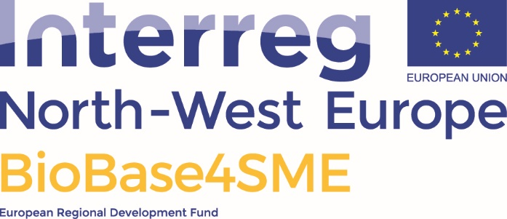

BioBase4SME Coupon Agreement

Contents

1. Between: 2
2. Purpose of the document 2
3. Description of coupon services 3
1. Bio Base Europe Pilot Plant 3
2. TCBB Resource 3
3. Materia Nova 3
4. NNFCC, the bioeconomy consultants 3
5. Association des Chambres d’Agriculture de l’Arc Atlantique 3
6. Rewin projecten BV 3
4. Signatures 4

- Between:
The coupon receiver
[Name SME], with its principal place of business at [address] and duly represented by [Name legal representative].
The service providers
BIO BASE EUROPE PILOT PLANT, with its principal place of business at Rodenhuizekaai 1, 9042 Ghent and duly represented by Luc Helsen, Financial Manager.
TCBB Resource, with its principal place of business at [address] and duly represented by [Name legal representative].
Materia Nova, with its principal place of business at [address] and duly represented by [Name legal representative].
NNFCC, the bioeconomy consultants, with its principal place of business at [address] and duly represented by [Name legal representative].
Associations des Chambres d’Agriculture de l’Arc Atlantique, with its principal place of business at [address] and duly represented by [Name legal representative].
REWIN projecten BV, with its principal place of business at [address] and duly represented by [Name legal representative].

- Purpose of the document
The project BioBase4SME (www.nweurope.eu/projects/bio-innovation-support-for-entrepreneurs-throughout-nwe-regions) is offering innovation coupons to SME’s and start-ups, after a selection procedure. When granted, these coupons provide access to innovation services for obtaining proof-of-concept of a promising technology, and for developing a strong business strategy. This document (the BioBase4SME Coupon Agreement) stipulates the exact service that will be provided by each service providers, and the value of that service. This document needs to be signed by legal representatives of all parties involved (the coupon receiver, and the service providers) before any coupon work will start.

- Description of coupon services
- Bio Base Europe Pilot Plant
Bio Base Europe Pilot Plant http://www.bbeu.org/pilotplant/ | Service value  50% covered by project
Technological scale-up and industrial proof-of-concept
Description of service

- TCBB Resource
TCBB-Resource  website | Service value  100% covered by project
Anaerobic digestion and pyrolysis tests
Description of service

- Materia Nova
Materia Nova  website | Service value  50% covered by project
Life Cycle Analsyis:
Description of service

NNFCC, the bioeconomy consultants
NNFCC, the bioeconomy consultants  website | Service value  50% covered by project
NNFCC is a specialist Bioeconomy consultancy
Description of service

- Association des Chambres d’Agriculture de l’Arc Atlantique
Association des Chambres d’Agriculture de l’Arc Atlantique - website | Service value  50% covered by project
Social acceptance
Description of service

- Rewin projecten BV
Rewin projecten BV  website | Service value  100% covered by project
Application testing’
Description of service

- Signatures
The coupon receiver

[Name organisation]
Place and date:
Name and function of the signatory:
Signature/Stamp:

Bio Base Europe Pilot Plant
Place and date:
Name and function of the signatory:
Signature/Stamp:

TCBB Resource
Place and date:
Name and function of the signatory:
Signature/Stamp:

Materia Nova
Place and date:
Name and function of the signatory:
Signature/Stamp:

NNFCC, the bioeconomy consultants
Place and date:
Name and function of the signatory:
Signature/Stamp:

Association des Chambres d’Agriculture de l’Arc Atlantique
Place and date:
Name and function of the signatory:
Signature/Stamp:

REWIN projecten BV
Place and date:
Name and function of the signatory:
Signature/Stamp:

